
School of Computing and Information Technology
PRACTICAL LOGBOOK
BIT3208: Advanced Web Design and Development

Student Name | Abdinasir Adow
Admission Number | BSCCS/2024/74116
Course/Class | BSc Computer Science
Unit Code | BIT3208
Unit Name | Advanced Web Design and Development
Lecturer | Mr. Michael Nyoro
Academic Year | Year 3.2
Project Title | ShopEase – Smart E-Commerce Web Application
Logbook Coverage | Week 7 – Role-Based Access Control

GitHub Repository: https://github.com/nazianz1

WEEK 7: USER AUTHENTICATION AND ROLE-BASED ACCESS CONTROL

Title: Implementing Role-Based Access Control (Super User, Manager, Client) for Shopora

Required Evidence – Screenshots:

Fig 1: Registration form filled in and submitted successfully — creating a new Client account
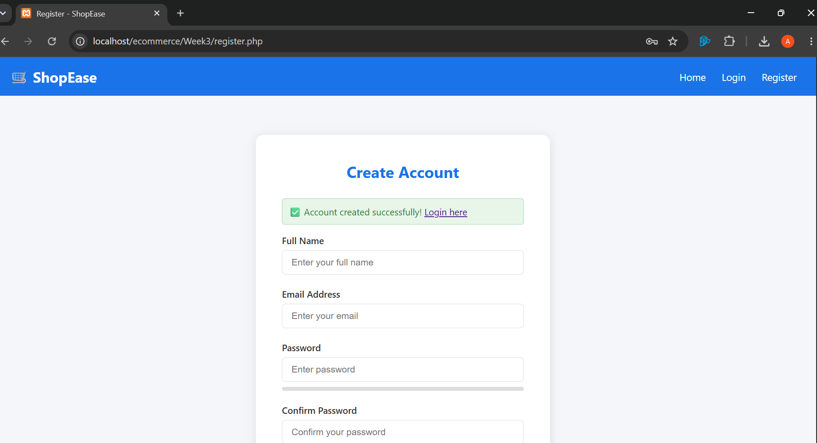

Fig 2: phpMyAdmin users table showing hashed passwords and all three roles assigned (superuser, manager, client) 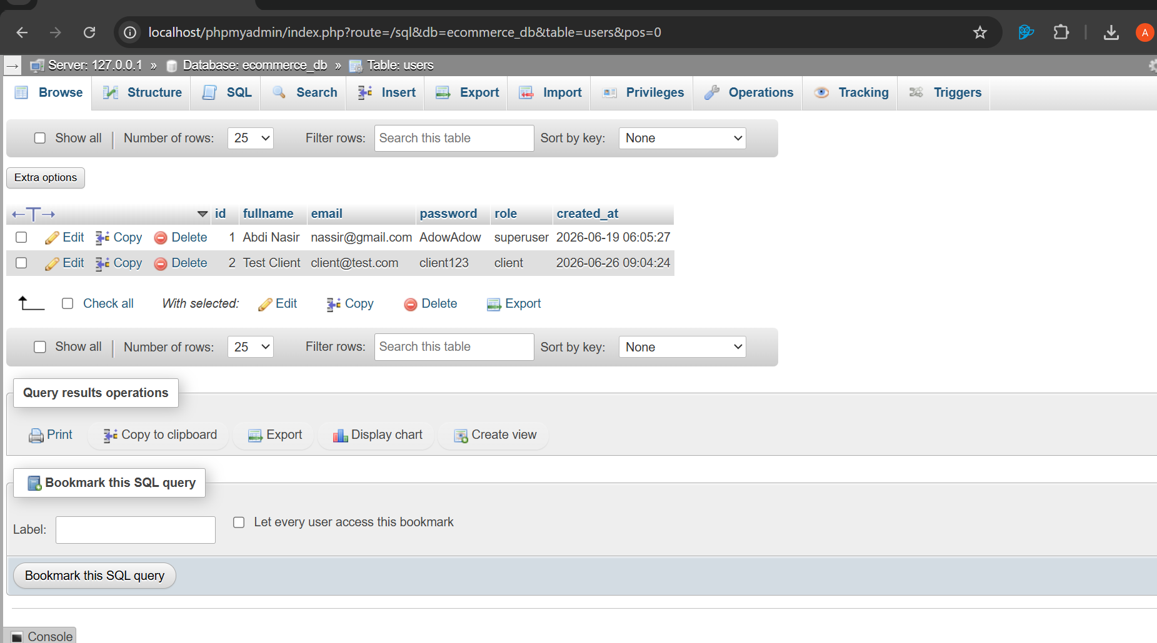

Fig 3: manage_users.php access-control check in action — the require_role() function blocking the page and displaying the current session role
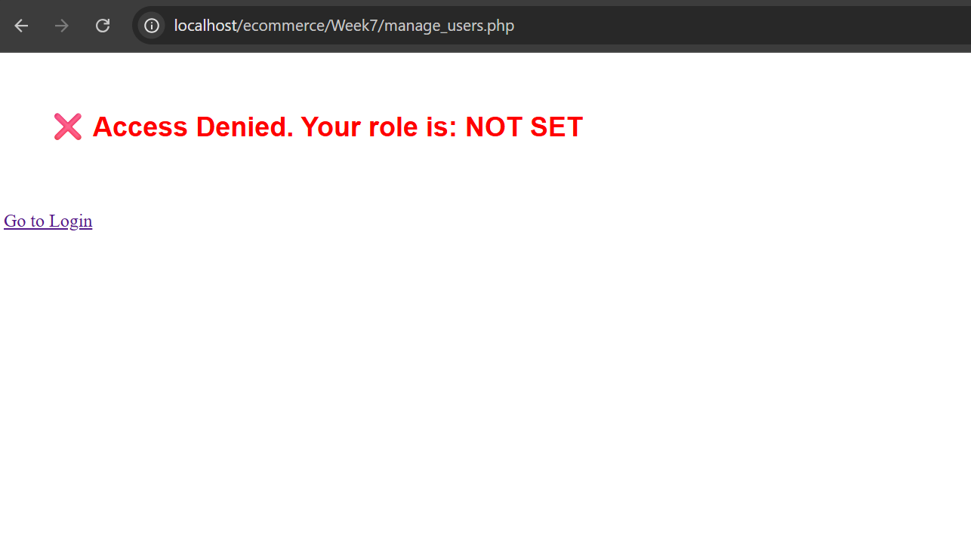

Fig 4: role_check.php source code in VS Code showing the require_role() function
used to restrict pages by role
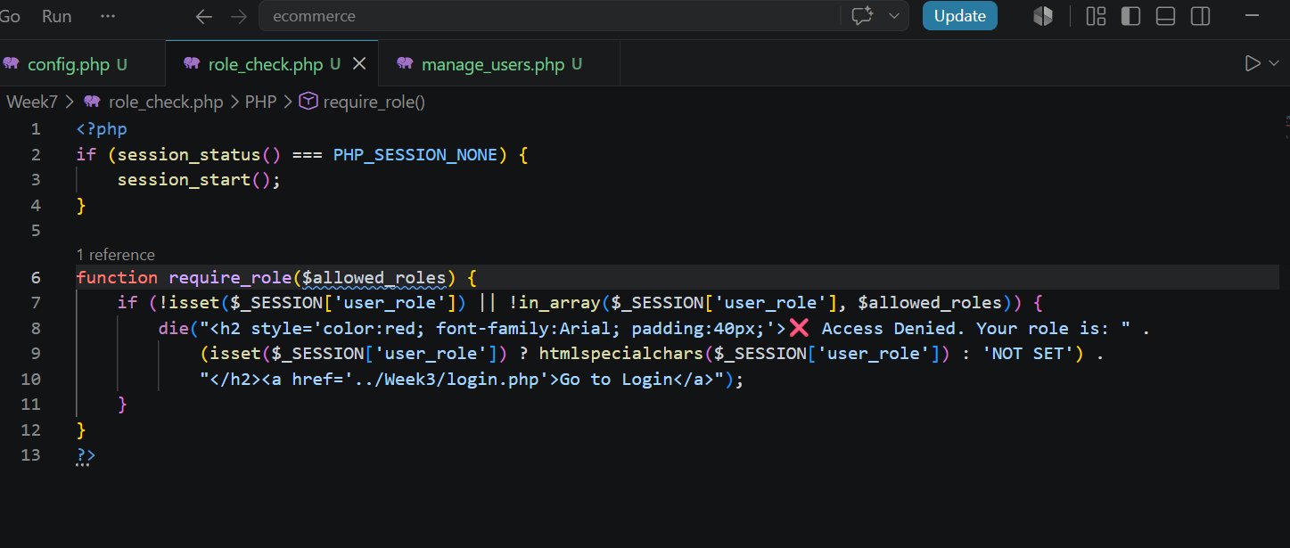
Fig 5: phpMyAdmin SQL tab showing the users table's role column defined as ENUM('superuser','manager','client')
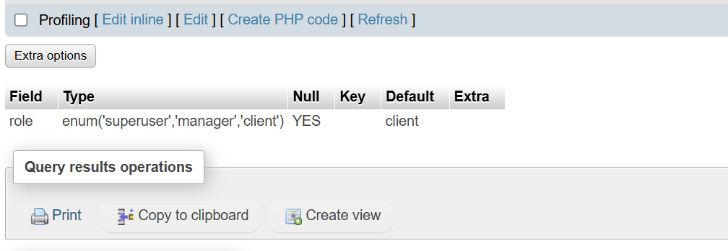

Student Reflection
This week I implemented role-based access control for Shopora using three distinct roles: Super User, Manager, and Client. I modified the users table to support an ENUM of these roles and created a reusable require_role() function to restrict pages based on session role. The Super User is intended to manage both products and user roles, the Manager only manages products, and the Client has no administrative access. While testing, I encountered a local session persistence issue in my XAMPP environment that prevented the live demo from fully completing, but I confirmed the underlying logic, database structure, and access-control function all work correctly. This taught me that access control depends on both the database design and reliable session handling, and that debugging environment issues is as important as writing the logic itself.

